EXPENSE REIMBURSEMENT FORM TEMPLATE
The first page sets the context and rules for the expense reimbursement.
- Purpose: The template is for any expense reimbursement made by committee members of the Malaysian Society (MSOC XX).
- Timeline:
  - Submission: Claims must be submitted within 1 week after the event's conclusion. Proof of receipt is crucial.
  - Processing: Reimbursement may take up to 2 weeks to complete after the event ends, provided all necessary receipts and supporting documents are attached.
  - Late Submissions: Claims submitted after the 1-week period will not be entertained.
- Notice/ Disclaimer: MSOC XX is not responsible for unforeseen incidents, and additional costs incurred due to such circumstances will not be reimbursed.
- Contact: Members are directed to contact the Treasurer for any questions
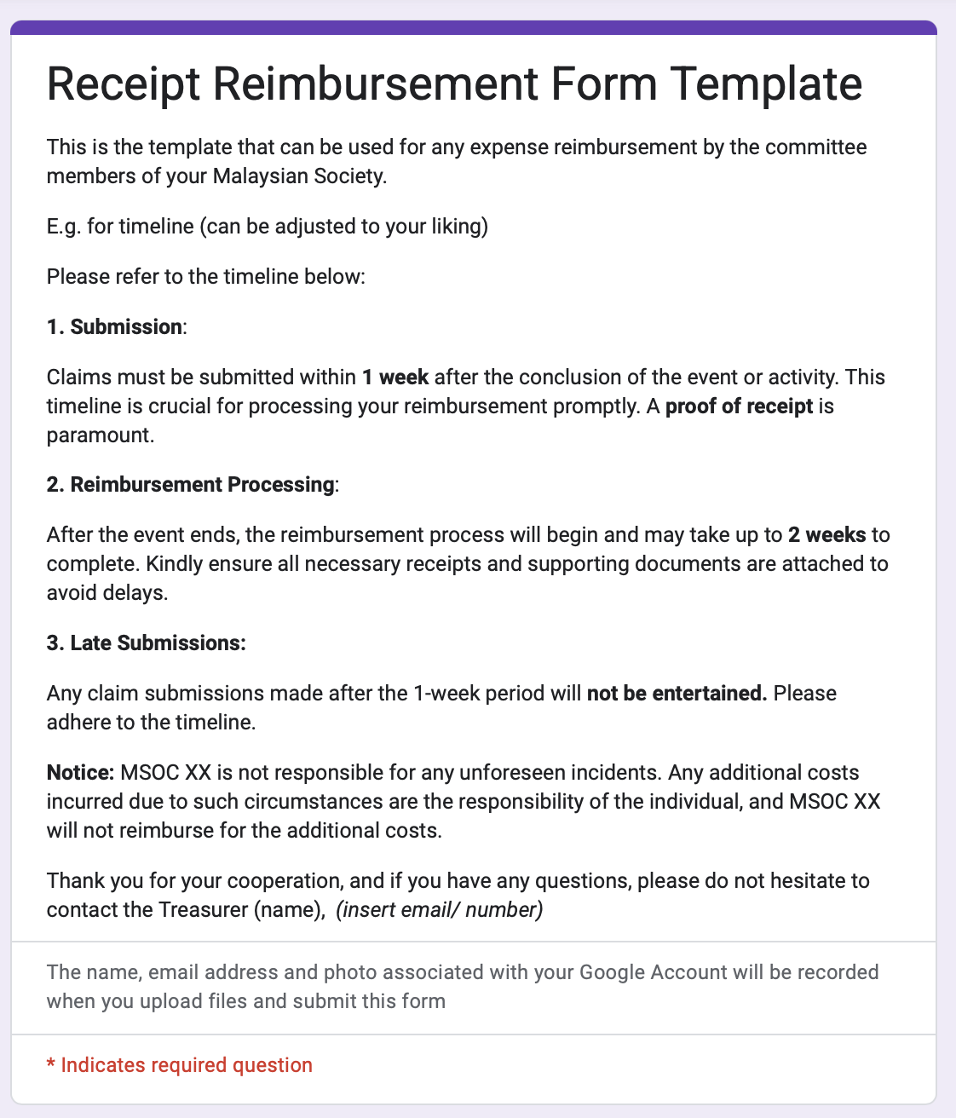
This section collects essential information about the claimant and the expense itself.
- Name and Office: Requires the claimant's name and their position/office (e.g., Ali - Event Co).
- Event: Uses a drop-down menu to categorize the expense. The options listed include "Other (Office uses, miscellaneous, etc.)" , "MNight" , and "MGames".
- Amount: Requests the amount to be reimbursed in Pounds (£'s). If claiming in Malaysian Ringgit, the claimant must mention this in the remarks

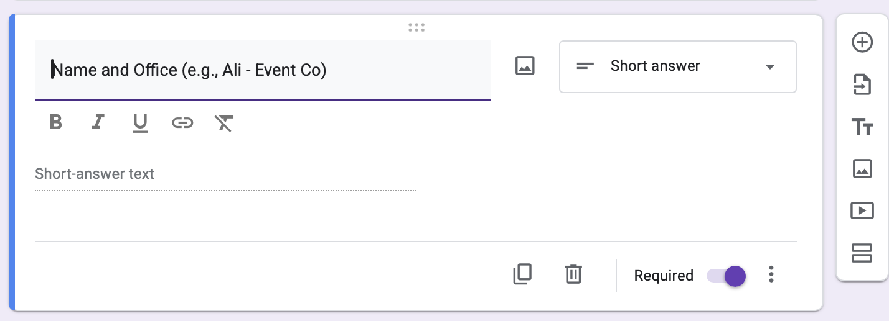
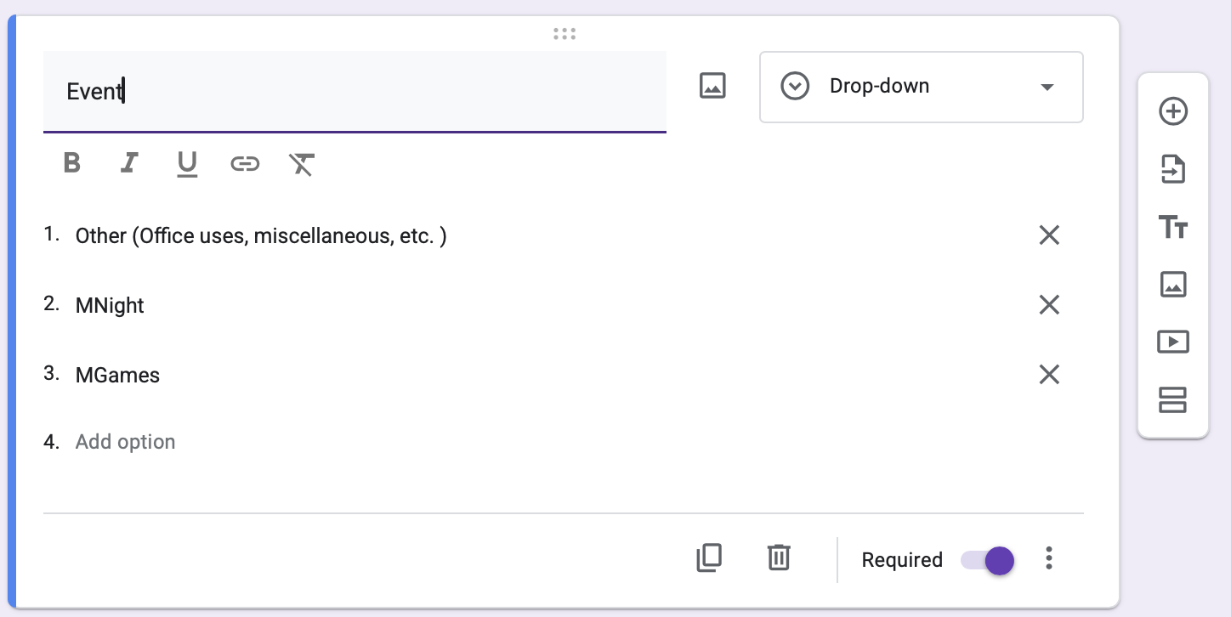
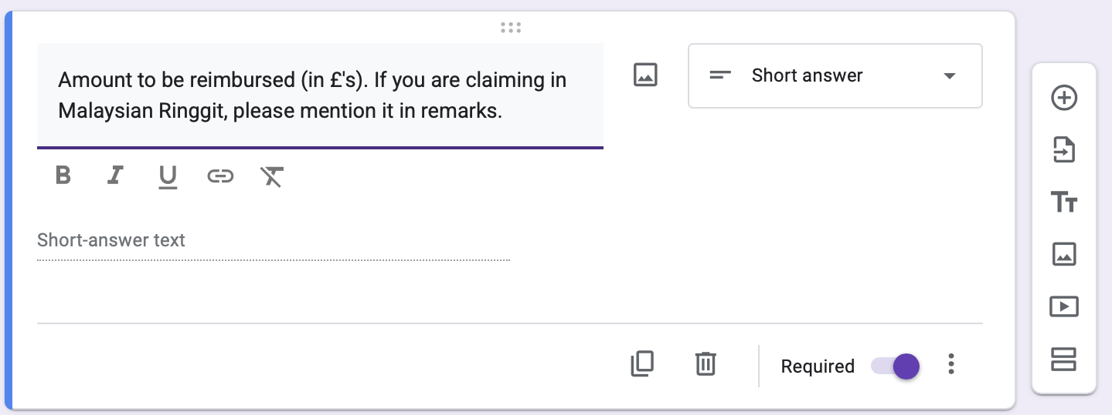
This section clearly defines the required banking information needed to process the payment, distinguishing between UK and MYR claims.
- UK Claims: Requires First Name, Last Name, Bank Account Number, and Sort Code. It also notes that BIC and IBAN are applicable to accounts in the Republic of Ireland (ROI) only.
- MYR Claims (Malaysian Ringgit): Requires the Bank Name, Account Number, and Full Name
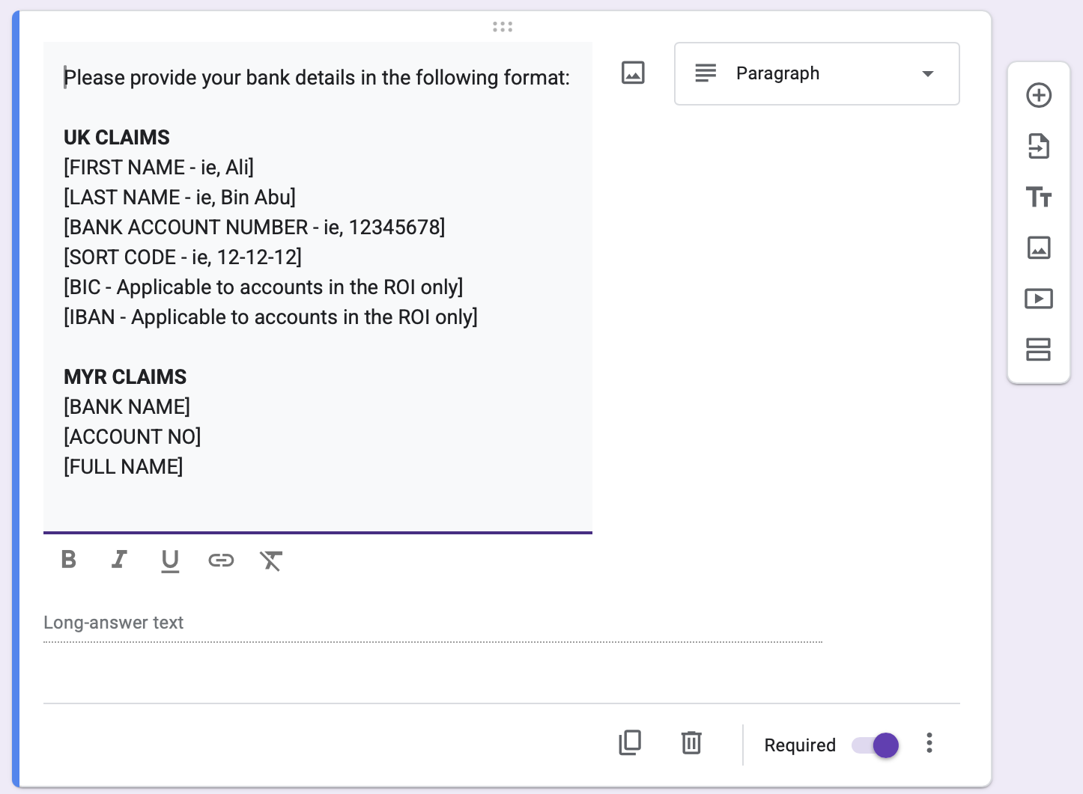

This final section details the proof of purchase requirements and instructions for uploading receipts.
- Evidence Required: Evidence is REQUIRED for reimbursement. This includes receipts or e-receipts that state the AMOUNT PAID and the DATE OF PURCHASE.
- Receipt Labeling: Claimants must rename the receipt title as "[EVENT NAME] - Name" (e.g., "MGames - Ali").
- Multiple Receipts: If there are multiple receipts, they must be combined into a single PDF.
- File Upload: Make sure the form accepts file uploads up to 10 MB, with a maximum of 1 file.
